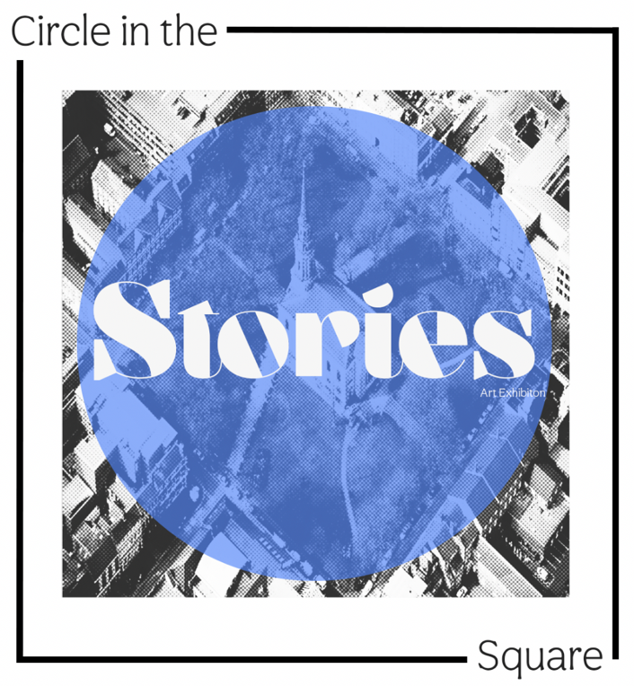
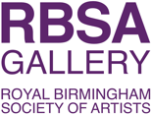
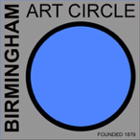

HOW TO ENTER
Please use the link below to access the BAC Stories Exhibition Entry application to record details of your entries, and then pay the appropriate entry fees by back transfer to
Account name : Birmingham Art Circle
Sort code: 40 - 12 - 24
Account No. 71109235
Reference: Your name

https://form.jotform.com/BirminghamArtCircle/bac-stories

WORK ALLOWED
The Birmingham Art Circle 3 year no repeat showing rule applies. (No work exhibited recently at the RBSA - from 2023 to the present can be shown)

NUMBER OF WORKS ALLOWED
2-dimensional – maximum 4 works (Works of 150cm or more are restricted to 2 entries.)
3-dimensional – maximum 4 works.

SUBMISSION FEES
The cost of entry for 2D and 3D work: 1 exhibit = £10, 2 = £16, 3 = £20, 4 = £24.
A large 2D artwork is charged the same as 2 small works.

COMMISSION
Charged at 30% (20% to Birmingham Art Circle, 10% + VAT to RBSA)

ARTIST STATEMENTS
Please give us a single statement to cover your practice and all of your entries. The Stories Exhibition Application will allow you to enter up to 250 words for this purpose.

HANDING IN
Work must be delivered to the RBSA on Sunday 1st November 3pm - 5pm. If you are unable to deliver your work in person it is essential that you make alternative arrangements for its delivery at this time.

SUITABILITY OF WORK FOR THE EXHIBITION
All submissions should be original work. Although it is expected that submissions will be of the usual high quality the committee reserves the right to withdraw any work that is considered to be clearly below acceptable standards or unsuitable on health and
safety grounds.

HANGING REQUIREMENTS FOR 2-DIMENSIONAL WORK
All 2D works should be fitted with mirror plates positioned midway down each side. Please be accurate with this to facilitate hanging. Please ensure mirror plates are securely attached and painted white before handing in your work.

NUMBERS AND LABELS
You should attach two labels to the back of each work showing the following information:
1. Artist’s name
2. Title of Work
3. Price
One of these labels should hang over the front for identification/numbering.

INSURANCE
Neither the Art Circle nor the RBSA Gallery will be responsible for loss or damage to member’s work. Members are strongly advised to insure their own work against theft or damage.

REMOVAL OF EXHIBITS
Please collect your work on Sunday 15th November between 12.00 pm and 2.00 pm. All work must be collected no later than the stated time. If you are unable to collect your work in person it is essential that you make alternative arrangements for its collection at this time. Neither the Art Circle nor the RBSA Gallery will be responsible for uncollected work. The RBSA is entitled to charge for storage of uncollected work.

KEY DATES
Entry Form Application Deadline | Monday 19th October
Delivery of Work | Sunday 1st November - 3pm - 5pm
Private View | Saturday 7th November – 2pm – 4pm
Collection of Unsold Work | Sunday 15th November – 12.00pm – 2pm

